Installing the Dev Board Downloader: stcgal-csulb and CH340 Driver:
- Download the stcgal-csulb setup from www.engreric.com and run it.
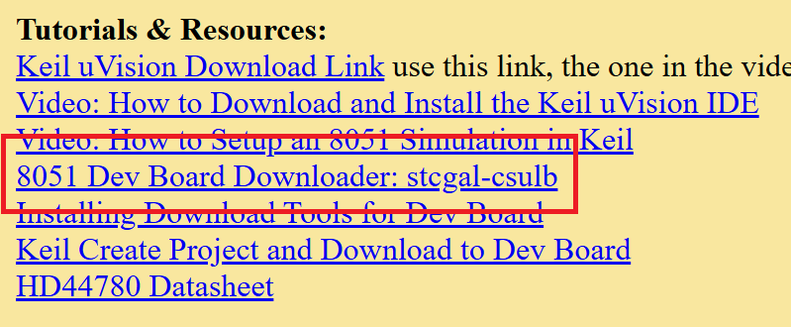
You may be presented with a window from Windows Defender, make sure to click “More Info” and then “Run Anyway”.
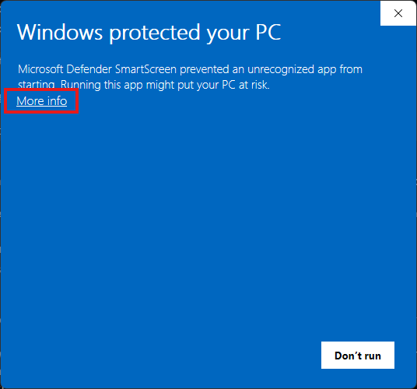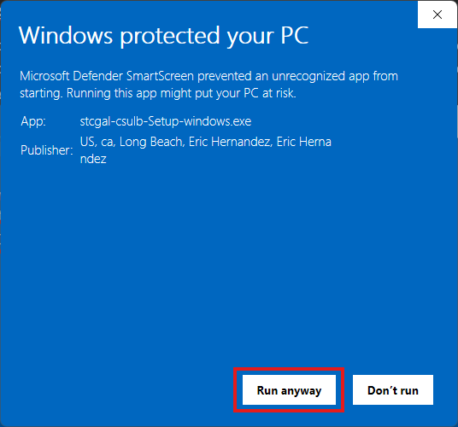

- Accept the license agreement to continue with installation.
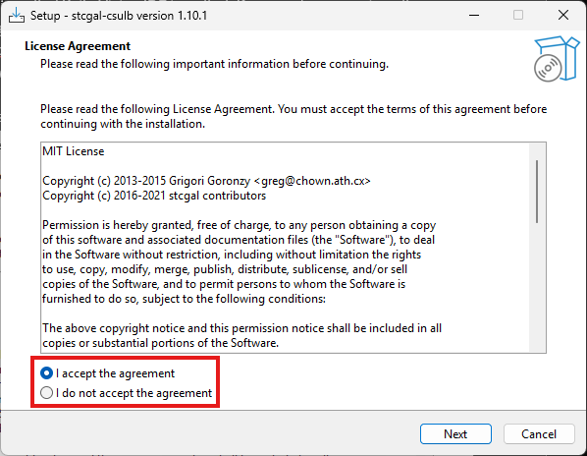
- Select which items to install. If this is your first time installing the software, you will likely need to select both stcgal and the CH340 USB driver to install. The CH340 USB driver is necessary for your computer to recognize the dev board as a device and stcgal is the software we will be using to upload code to the board. Note: It is safe to reinstall the driver over another, windows will choose the latest.
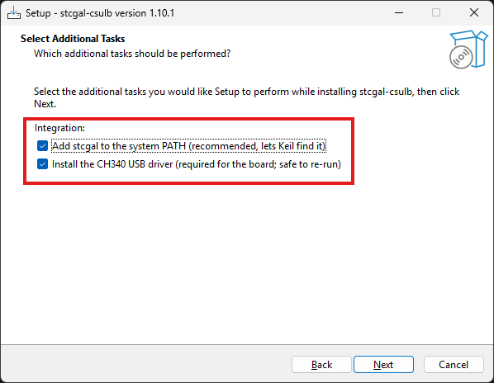
- After your selection is made, click “Install” to install the selected programs.
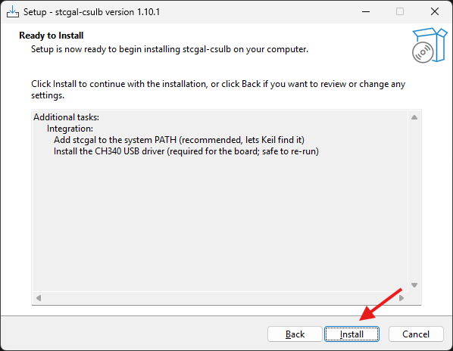
- If you have selected to install the CH340 USB driver, you will be presented with a new window to install them. Click “Install” on this new window to install the CH340 USB driver.
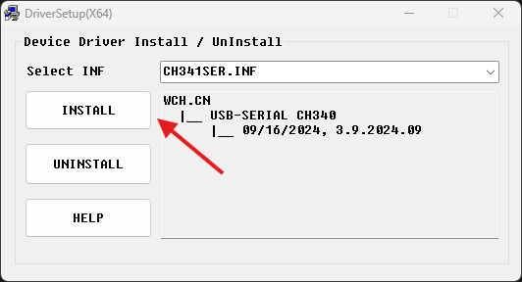
- After installation is complete, you may close out of the window for the CH340 driver setup and click “Finish” on the installer. By keeping “View Keil-Setup.txt” selected, it will open a text file containing information on working with stcgal in Keil uVision IDE.
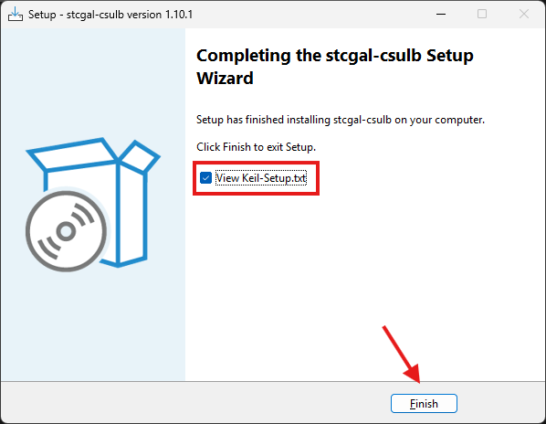

Creating Keil uVision Project and Setting the Downloader: stcgal

- Start Keil. Navigate to the Project menu and click New μVision Project.
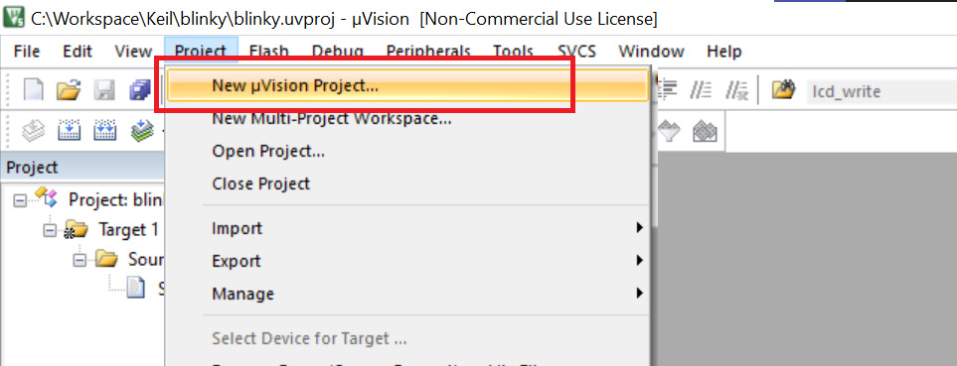
- Name your project and click Save.
Note: ALWAYS save the project file (*.uvproj) to it’s own folder with no other projects in it. Failure to give it it’s own empty project folder will result in multiple projects “competing” to overwrite each other’s files.

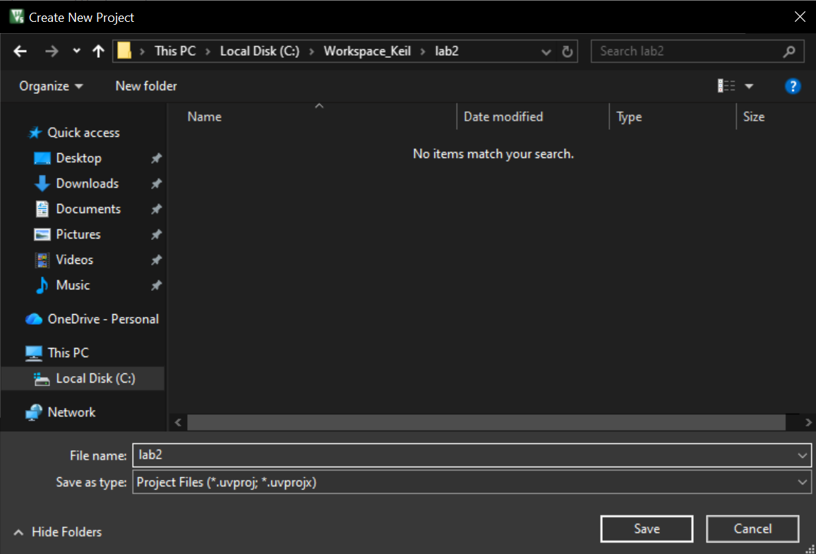
- When prompted to select a device, type 8052 in the search bar. Select 8052 (all Variants) under Generic. Click OK.
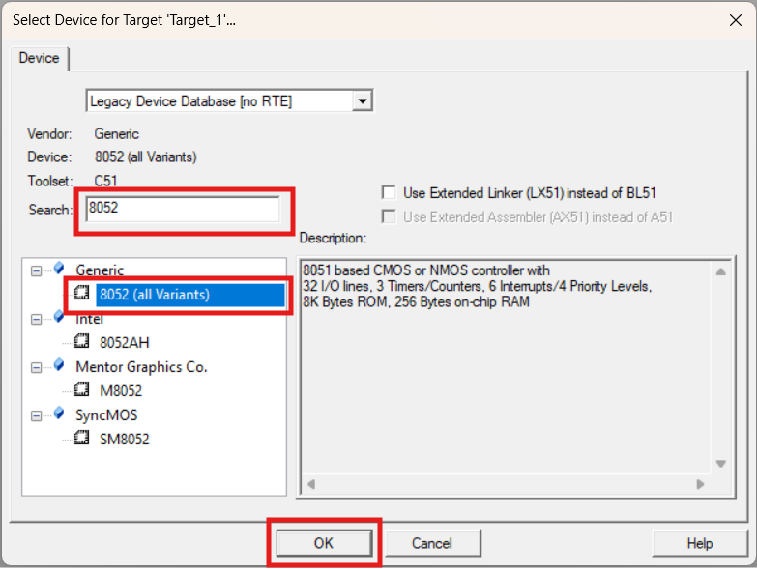

- Right-click Target_1 in the Project panel on the left. Select Options for Target ‘Target_1’
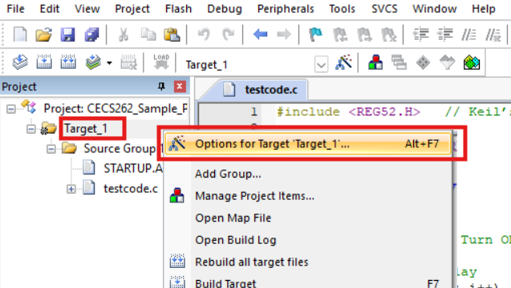

- Navigate to the Output tab. Check the box next to Create HEX file.
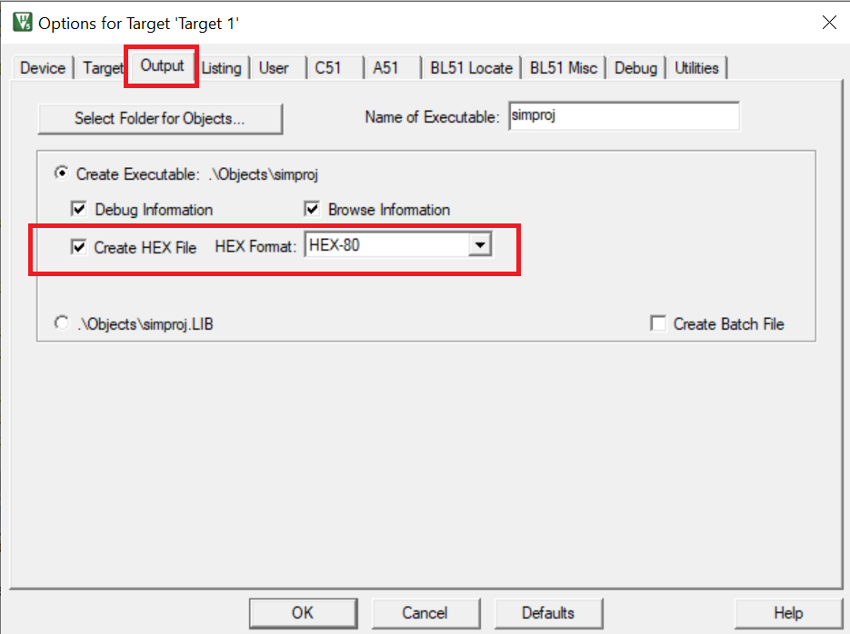

- Navigate to the Utilities tab. Select Use External Tool for Flash Programming. In the Command text box, enter the command stcgal, and in the following Arguments text box, enter -P stc89 -b 38400 -a "#H". Then click OK to save your changes. This allows Keil to use stcgal to flash the program to the 8051 board with the hex file Keil creates when you build your target. NOTE: You must do this every time you create a new uVision project. Click OK when done.
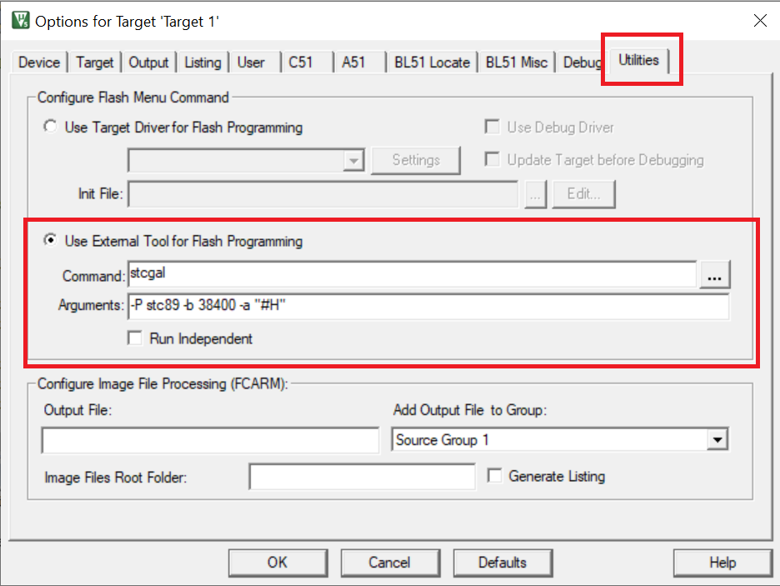

- In the Project files browser on the left, right-click on Source Group 1 and Add New Item
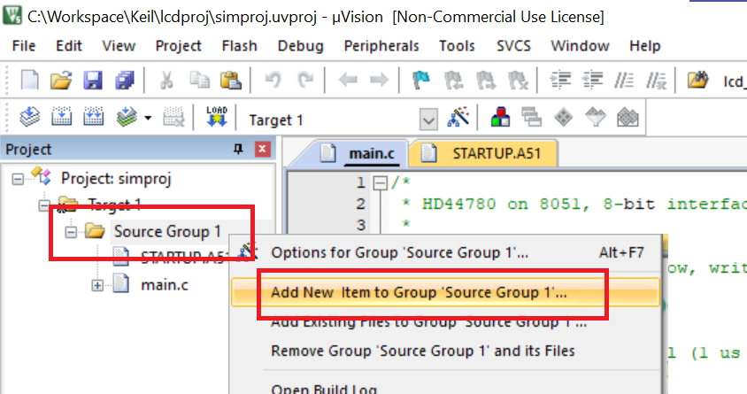

- Select C File (.c) and name it “main”, Keil will automatically append the .c extension. Click Add

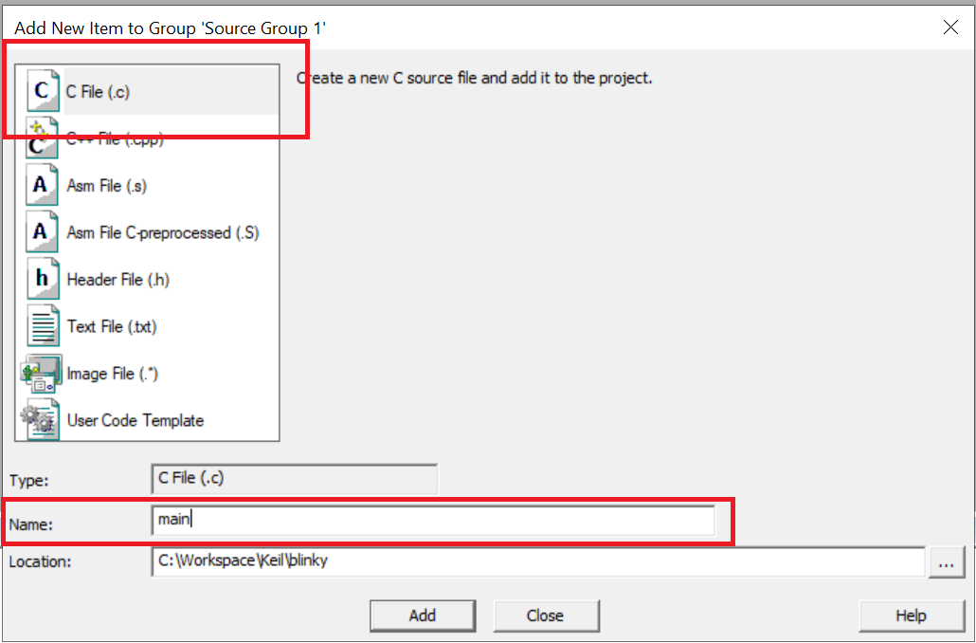

- In the editor, add the following “blinky” test code to main.c

// Blinky Test Code: Causes the built in LED(P1.0) to blink
#include <REG52.H>

void main(void){
unsigned int i;
unsigned char j;

while(1){

P1 = 0xFF; //Set P1.0 to P1.7 High/5v: LED Off

//Busy-Wait Delay
for (i = 0; i < 500; i++){
for (j = 0; j < 255; j++);
}

P1 = 0x00; //Set P1.0 to P1.7 Low/0v: LED On

//Busy-Wait Delay
for (i = 0; i < 500; i++){
for (j = 0; j < 255; j++);
}

}

}

- Click the Rebuild button in the upper left corner menu to recompile your program.

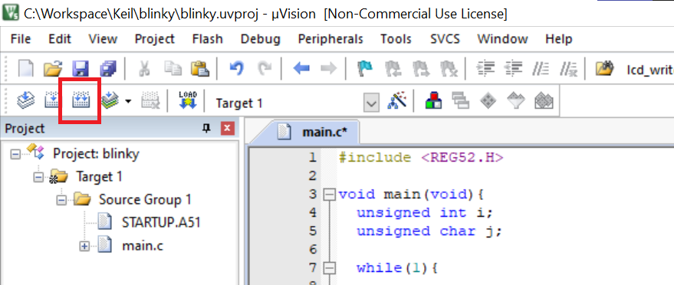

- Make sure compiling was successful and you see: 0 Error (s), 0 Warning (s).
Note: If you see errors then your program did not compile successfully and no hex file will be created. If no hex file was created then you can’t download to the board.

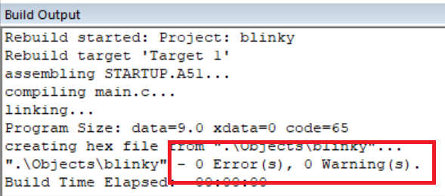

- There are two ways to download your program to the 8051 board:
  - Click the Load button in the top left corner as shown in the screenshot below.
  - Or, you can simply press the F8 key to do the same action

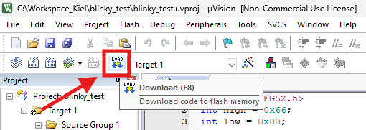

- Ensure the Download Was Successful, you can scroll to see that Flash Programming completed at 100%

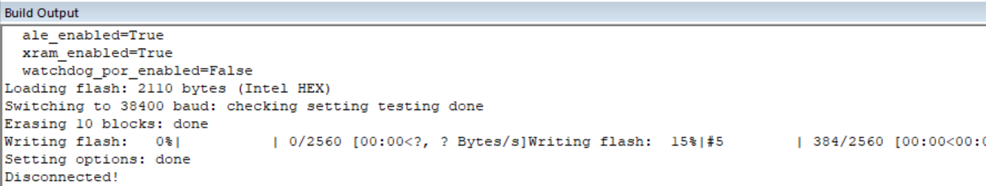

Congratulations You Have Successfully Downloaded to the Development Board

