NAME: POSSIBLE POINTS: 10

STUDENT ID:

COURSE DATE & TIME:

### OBJECTIVE:

* To learn how to create and simulate a circuit in LTSpice.
* Ohms Law, Voltage, Current, Resistance

### DIRECTIONS:

Step 1 – Calculate the following circuit by hand.

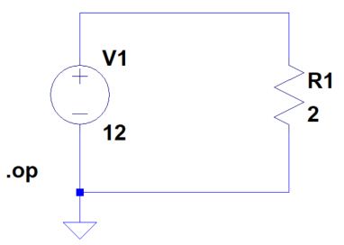

IR1 “Current Through R1” = ______________

VR1 “Voltage Across R1” = ______________

Please show any equation that is required to solve by hand.

Step 2 – LTspice Model/Simulation.

Open LTSpice.

Now create a new circuit, File -> New Schematic.

Save this file as lab1.asc to a safe location.

Add a Voltage Source (V1) of 12V and a Resistor (R1) of 2 ohms.

Use the wiring tool to connect V1 to R1

Now before we can run the simulation we need to add 2 things.

* A GND symbol is necessary for the simulation to “know” at which point of our circuit we are considering to be 0V
* Edit the simulation command

Step 2A – DC Operating Point Analysis

Before we can run the simulation, we need to select the simulation type. For our first run, we will select the DC Operating Point Analysis – “DC op pnt”. Select this type of analysis. Run the Simulation and include a screenshot of the output. For each line of the output, please include at minimum 1 sentence describing what the line mean.

- Include Screen Shot and Here -

Description of Results:

Step 2B – Transient Analysis

Next we will change the simulation type to Transient Analysis, right-click on the op command and change the tab to Transient. For the simulation to run, at minimum we will have to enter a stop time. A 1 sec run time will work fine for this.

Run the Simulation and notice we now have a waveform. Plot IR1 and VR1 on the waveform. Notice that Voltage will be shown along the y-axis on the left while Current will be shown on the right. Now inspect the I(R1) signal by clicking on the signal name in the waveform window, another window will appear displaying the precise value of the signal at the desired time, you can move this at different points to see the value at any point in time. Include a screenshot of the waveform, schematic, and inspection window (displaying the value of I(R1).

- Include Screen Shot and Here -

Do the results of the Transient Analysis match the DC Operating Point and Hand Calculations?

Deliverables - Lab Write-Up:

The lab write-up will consist of this document filled out, printed and submitted.