NAME: POSSIBLE POINTS: 10

STUDENT ID: Course Date & Time:

Step 1: Solve the Circuit By Hand

You may solve this circuit on this page or include it on a separate page:

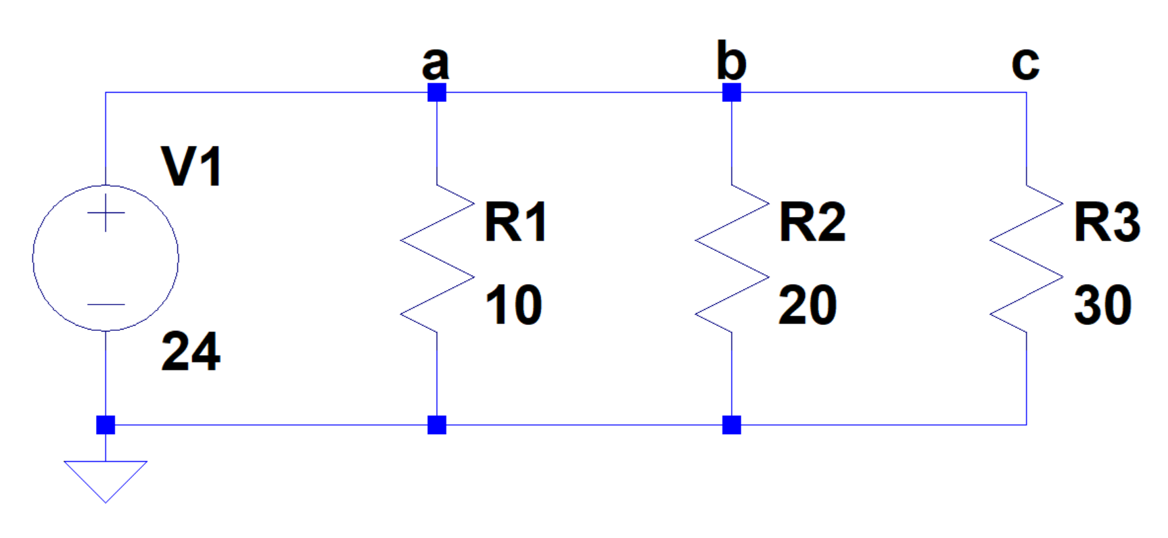

Fill in the following table and questions:

|  |  |  |  |
| --- | --- | --- | --- |
| RT |  | The Following 3 voltages are the voltages at node a,b,c. | |
| IT |  |
| IR1 |  |
| IR2 |  |
| IR3 |  |
| VR1 |  | Va |  |
| VR2 |  | Vb |  |
| VR3 |  | Vc |  |
| PR1 |  |  |  |
| PR2 |  |  |  |
| PR3 |  |  |  |

How Many KVL Loops exist? _______

Write an equation for each KVL Loop :

Why is VR1, VR2, VR3 the same?

Step 2: Create LTSpice Circuit and Run DC Operating Point Analysis

Open LTSpice and create the above circuit. Use the “Label Net” tool to label nodes a,b,c as shown in the circuit. Run a DC Operating Point Simulation.

– Include Screenshot of the Results Here –

From these results, fill in the following 3 values from your simulation

IR1 : ___________________ IR2 : ___________________IR3 : ___________________

Do these match your calculated values from Step 1? __________________________

Now add up the Currents IR1 + IR2, + IR3 = ________________

Does this equal your calculated IT from Step 1? __________

What is the rule that tells us that IR1 + IR2, + IR3 = IT ?____________________________

Step 3: Transient Analysis

Change the LTSpice simulation to a Transient Analysis with a 1sec runtime and run.

Take a voltage measurement at the following nodes, inspect the signal to get the precise value and record the values. There is no need to include a screenshot yet.

|  |  |
| --- | --- |
| Va |  |
| Vb |  |
| Vc |  |

Do these match step 1 and 2? ______________

Now take a Current Measurement of R1, R2, R3 and inspect the signals to get the precise value. Record these in the following table.

|  |  |
| --- | --- |
| IR1 |  |
| IR2 |  |
| IR3 |  |

Do these match the results from step 1 and 2? ______________

Take a screenshot of the circuit with the waveform showing the 3 current measurements. An inspection window is not necessary to show.

– Include Screenshot Here –

Deliverables - Lab Write-Up:

The lab write-up will consist of this document filled out and submitted.