NAME: POSSIBLE POINTS: 10

STUDENT ID:

COURSE DATE & TIME:

### DIRECTIONS:

Solve the following circuits by hand, write the answers on the lab and staple the handwritten work with the lab when you submit the write-up. You may round resistances to 2 decimal points of precision.

1) Find the Total/Equivalent Resistance - Rt for the following circuits:

|  |  |
| --- | --- |
| Rt = __________ | Rt = __________ |
| Rt = __________ | Rt = __________ |

2) For each of the figures, find the Total/Equivalent Resistance - Rt between points A and B.

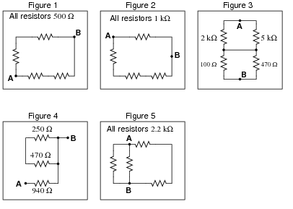

Figure 1: Rt = ____________ Figure 4: Rt = ____________

Figure 2: Rt = ____________ Figure 5: Rt = ____________

Figure 3: Rt = ____________

3) Calculate the reading on the Digital MultiMeter – DMM. Note that the button on the multimeter selects the property (Voltage, Resistance, Current) being measured. Also note that in order to measure Resistance we do not have a power supply attached to our circuit (there is no Supply Voltage (Vs)). In a real circuit under test the same would be true, power would have to be disconnected. Ignore the 5% next to the value on each component/resistor.

|  |  |
| --- | --- |
| DMM Measured Resistance: _____________ | DMM Measured Resistance: _____________ |

3) Calculate the readings on the two DMMs for the following circuit. Note that in order to measure current with a DMM, we must cut the wire and insert our DMM in series. In other words XMM2 (The 2nd Multimeter measuring Current) is completing the circuit between R4 and the negative side of our DC voltage source.

1. Voltage:__________ b) Current:__________

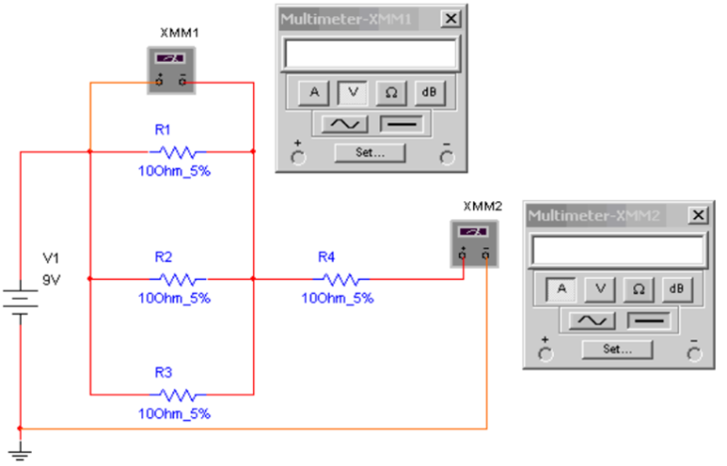

1) Calculate Current and Voltage for all resistors in the following circuits, you may round to 2 decimal points:

|  |  |
| --- | --- |
| V1 = 12v  VR1 = ________ IR1 = ________  VR2 = ________ IR2 = ________  VR3 = ________ IR3 = ________ | V1 = 35v  VR1 = ________ IR1 = ________  VR2 = ________ IR2 = ________  VR3 = ________ IR3 = ________  VR4 = ________ IR4 = ________ |
|  | V1 = 100v  VR1 = ________ IR1 = ________  VR2 = ________ IR2 = ________  VR3 = ________ IR3 = ________  VR4 = ________ IR4 = ________  VR5 = ________ IR5 = ________  VR6 = ________ IR6 = ________ |