NAME: POSSIBLE POINTS: 10

STUDENT ID:

COURSE DATE & TIME:

### DIRECTIONS:

We will be deriving the Thevenin and Norton equivalent circuit for the following circuit. Once we have the Thevenin and Norton equivalent circuits we will be using a Load Resistor as a test case in the Original Circuit, Thevenin Equivalent Circuit, and Norton Equivalent Circuit. If the Thevenin and Norton Eqivalent Circuits are indeed functionally equivalent then the Load Resistor (i.e. Test Case) should have the same Voltage across, and Current through in all 3 versions of the circuit: Original Circuit, Thevenin, and Norton equivalent circuits.

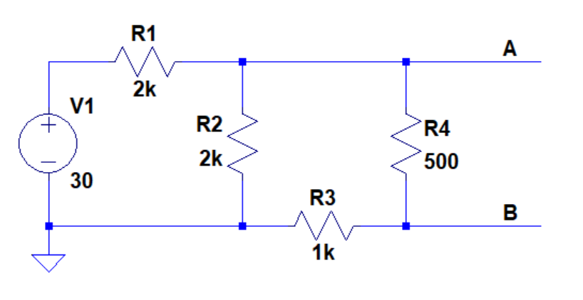

Step 1: Solve the above “Original Circuit” with a Load Resistor (RL) of 100ohms connected between terminals A and B. Include this hand calculated solution with the lab write-up and fill in the table at the end of the lab hand-out with VRL and IRL. Label this solution as Step 1.

Step 2: Use LTSpice to model the same circuit from Step 1 with RL. Include a screenshot of the circuit, waveform, and inspection window showing IRL. Record VRL and IRL in the table at the end of the lab hand-out and label the screen shot as Step 2.

Step 3: Now derive the Thevenin equivalent circuit for the above circuit by hand. Include this solution and clearly draw the resultant Thevenin Equivalent Circuit and label all values. Label this solution as Step 3.

Step 4: Solve the Thevenin Equivalent Circuit from Step 3 by hand with the added Load Resistor (RL) of 100ohms connected between terminals A and B. Include this hand calculated solution with the lab write-up. Record VRL and IRL in the table at the end of the lab hand-out and label this solution as Step 4.

Step 5: Use LTSpice to model the Thevenin Equivalent Circuit from Step 3 with the added load resistor RL of 100ohms across the terminals A and B. Include a screenshot of the circuit, waveform, and inspection window showing IRL. Record VRL and IRL in the table at the end of the lab hand-out and label the screen shot as Step 5.

Step 6: Now derive the Norton Equivalent Circuit for the original circuit by hand. Include this solution and clearly draw the resultant Norton Equivalent Circuit and label all values. Label this solution as Step 6.

Step 7: Solve the Norton Equivalent Circuit from Step 6 by hand with the added Load Resistor (RL) of 100ohms connected between terminals A and B. Include this hand calculated solution with the lab write-up. Record VRL and IRL in the table at the end of the lab hand-out and label this solution as Step 7.

Step 8: Use LTSpice to model the Norton Equivalent Circuit from Step 6 with the added load resistor RL of 100ohms across the terminals A and B. Include a screenshot of the circuit, waveform, and inspection window showing IRL. Record VRL and IRL in the table at the end of the lab hand-out and label the screen shot as Step 8.

Step 9: Verify that all the values agree and that the original circuit, the Thevenin equivalent and the Norton equivalent all produce the same results with our test load.

|  |  |  |  |  |  |  |
| --- | --- | --- | --- | --- | --- | --- |
|  | Calculations | LTSpice | Calculations | LTSpice | Calculations | LTSpice |
|  | Original Circuit | Original Circuit | Thevenin | Thevenin | Norton | Norton |
| VRL |  |  |  |  |  |  |
| IRL |  |  |  |  |  |  |

Deliverables: Please include this lab hand-out as a cover sheet with the table neatly filled in. Append your hand calculated solutions and LTSpice screenshots in the following pages with all steps neatly labeled and organized in sequential order of the steps. This Lab will be graded not only on the content, but also the organization, neatness and presentation.