NAME: POSSIBLE POINTS: 10

STUDENT ID:

COURSE DATE & TIME:

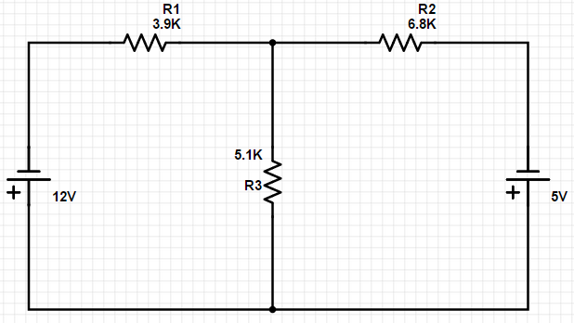

We will be doing this circuit as a breadboard prototype and eventually soldering it to a board. Make sure you have the above components. Resisters: 3.9K, 5.1K, and 6.8K. If you don’t have those values, it’s ok, just pick values that you do have and are close to the ones from the schematic. For example: If you don’t have a 5.1K, you might have a 5.2K. Make sure you annotate the above schematic with the changes. The solving and calculation portion of this lab must be done individually, but the prototyping and soldering will be done in groups.

Part 1:

Solve the above circuit using mesh analysis.

1. Label the assumed mesh currents (arbitrarily clockwise) on the above schematic
2. Derive the KVL expressions for the two loops. Write those below.
3. Solve the system of equations list the answers below.
4. Use the Mesh Currents you just solved for to derive the actual or real currents for your circuit. Draw an arrow and label these real currents on the following circuit.



1. Now use your real currents to find the voltage drop across each resistor and label these in the boxes below.

|  |  |
| --- | --- |
| VR1 |  |
| VR2 |  |
| VR3 |  |

1. How many KVL Loops are in the above circuit? ______________

For each loop, write the KVL expression below that shows it is equal to 0v.

1. Use your breadboard to prototype the above circuit. Verify the Current and Voltage Drop for each resistor. Write these measured currents and voltages below.

|  |  |
| --- | --- |
| I1 |  |
| I2 |  |
| I3 |  |
| VR1 |  |
| VR2 |  |
| VR3 |  |

1. We will solder a prototype during the lab session once the above has been completed. Before soldering we will have a short safety briefing, lecture, and demonstration of basic soldering skills. All supplies except for the resistors will be provided.