**Setting Up Keil and Downloading Test Code to Development Board**

**To Download Hex to Board:**  
You will need to download the program “Silicon Laboratories Flash Utility”

<https://www.silabs.com/developers/8-bit-8051-microcontroller-software-studio?tab=downloads>

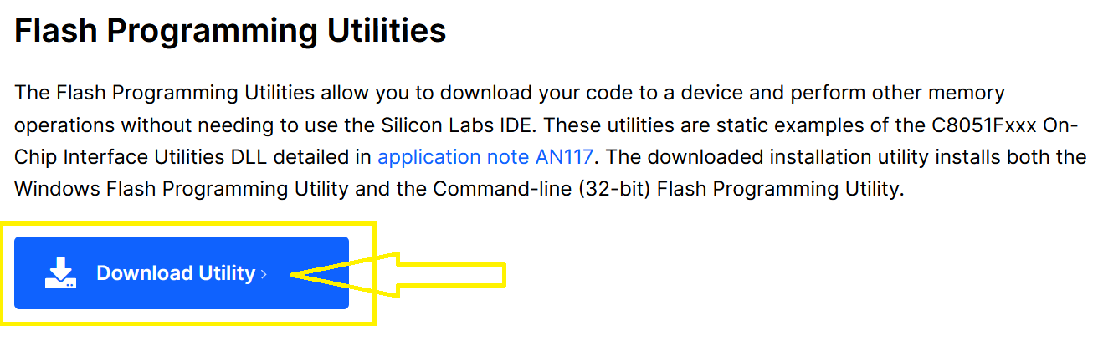

Under “Flash Programming Utilities” -> Download Software  
It may ask to register  
Download, Unzip and install

**Testing and Creating 1st project to download to the board:**

Now Start Up Keil uVision

//Create and setup the uVision Project  
Project -> New uVision Project

Device -> EFM8BB10F8G-QSOP24 and leave all settings to default  
It will Ask “Copy SILABS_STARTUP.A51 to Project Folder and Add File to Project?” Click Yes

//Setup Output to Generate Hex File and Add Include File Directory to C Compiler  
Right-Click Target 1 -> Options for Target

Click “Output” Tab  
Check the Box for “Create Hex File”

Click “C51” Tab  
In the box for “Include Paths” add:  
C:\Keil_v5\C51\INC\SiLABS\shared\si8051Base  
Or change the directory if you installed Keil uVision to a different location

Click “OK” at bottom

**TEST CODE:**

//main.c

#include <SI_EFM8BB1_Register_Enums.h>

void InitDevice(void)

{

//Disable Watchdog Timer with key sequence  
WDTCN = 0xDE; //First key  
WDTCN = 0xAD; //Second key

//Setup Defaults for P1  
P1MDOUT = P1MDOUT_B0__OPEN_DRAIN | P1MDOUT_B1__OPEN_DRAIN  
| P1MDOUT_B2__OPEN_DRAIN | P1MDOUT_B3__OPEN_DRAIN  
| P1MDOUT_B4__PUSH_PULL | P1MDOUT_B5__OPEN_DRAIN  
| P1MDOUT_B6__OPEN_DRAIN | P1MDOUT_B7__OPEN_DRAIN;

//Enable Weak Pullups  
XBR2 = XBR2_WEAKPUD__PULL_UPS_ENABLED | XBR2_XBARE__ENABLED;

//Disable Interrupts  
IE = IE_EA__DISABLED | IE_EX0__DISABLED | IE_EX1__DISABLED  
| IE_ESPI0__DISABLED | IE_ET0__DISABLED | IE_ET1__DISABLED  
| IE_ET2__ENABLED | IE_ES0__DISABLED;

}

main(void)

{

unsigned char x,y;

InitDevice();

while(1) //Infinite while loop, i.e. Superloop  
{

P1 = 0x55;

//Busy Wait Delay

for(x = 0; x < 0xFF; x++){

for(y = 0; y < 0xFF; y++){  
}

}

P1 = 0xAA;

//Busy Wait Delay  
for(x = 0; x < 0xFF; x++){

for(y = 0; y < 0xFF; y++){  
}

}

}  
}

**How to Download Hex File to Development Board:**

Run the Download Utility “Silicon Laboratories Flash Utility”

We first need to Connect to the board, make sure the board is connected via a micro usb cable.

Click on “Enumerate USB”  
Adapter Selection should say LCK0064019 or something similar  
Click on the radio button for “USB Debug Adapter”  
Click on “Connect”  
You should get a dialog box that says “Connected”, Click OK  
Click on the Tab “Download Hex File/Go/Stop”  
Click on “Browse” under “Download Filename”  
Navigate to where you saved your project, go into the “Object” Folder and select the Hex file that was generated by Keil  
Click on “Open”

Now Click on “Download”  
You should see a message that says “Succeeded Downloading Hex File, Checksum 0xXXXX”  
Click on OK  
Click on Go to Start Running the Code

You should see a blinking LED on the Board at this point