- Downloading and Installing the CH340 Driver:
  - Download the Windows-CH340-Driver.zip file from engreric.com
  - Open File Explorer → Downloads
  - Select the zip file and click “Extract all” from the menu.
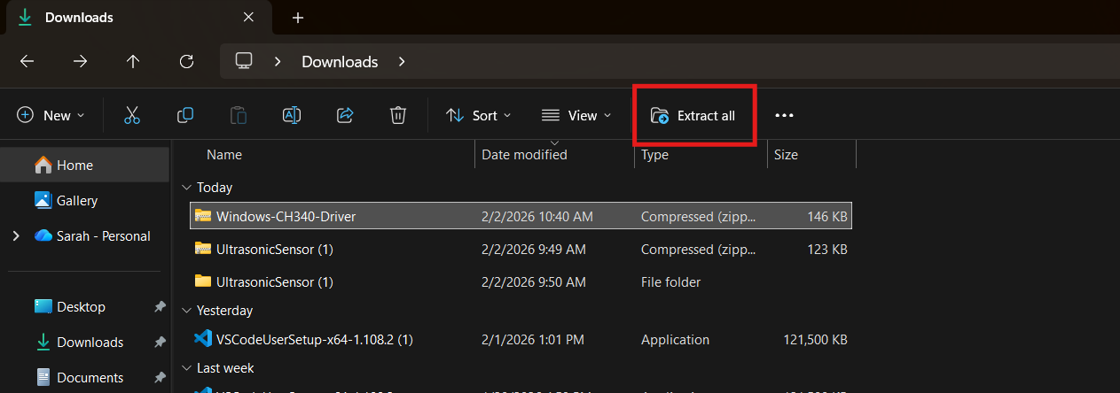
  - Select Extract on the window that pops up
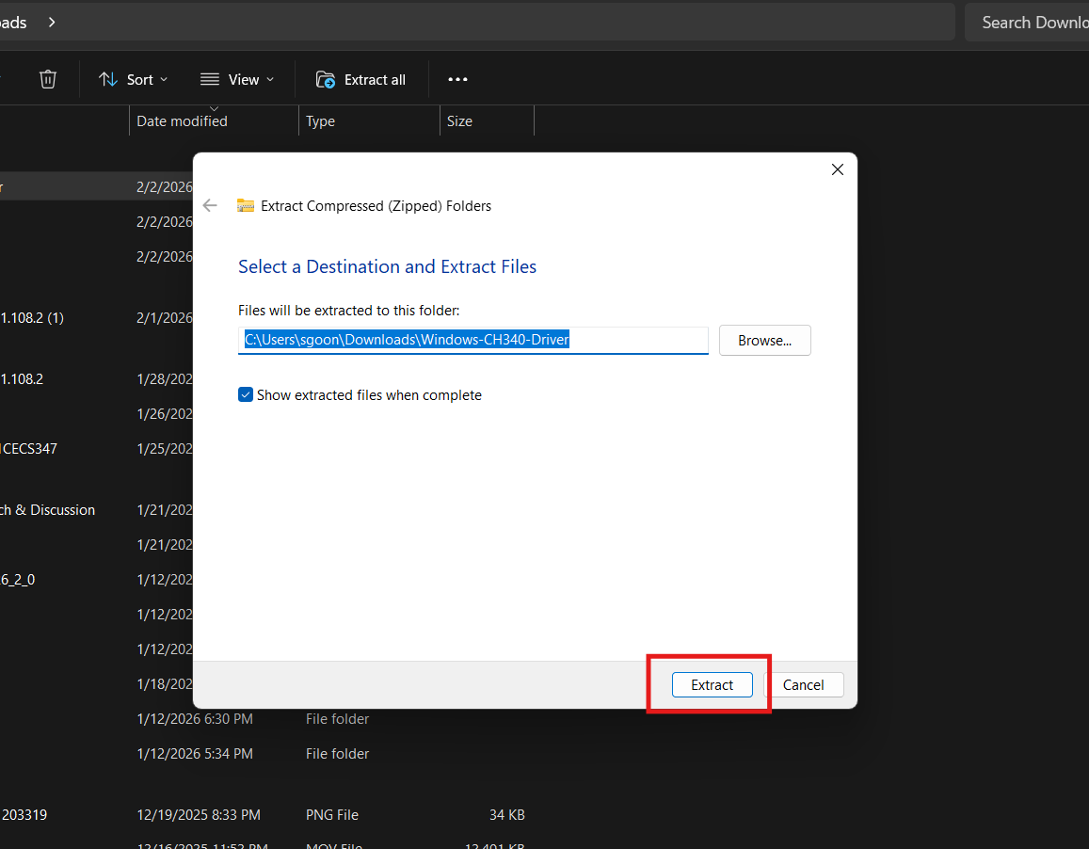

- You will now see a new folder called Windows-CH340-Driver. Open this folder. Double-click the SETUP Application to open it.
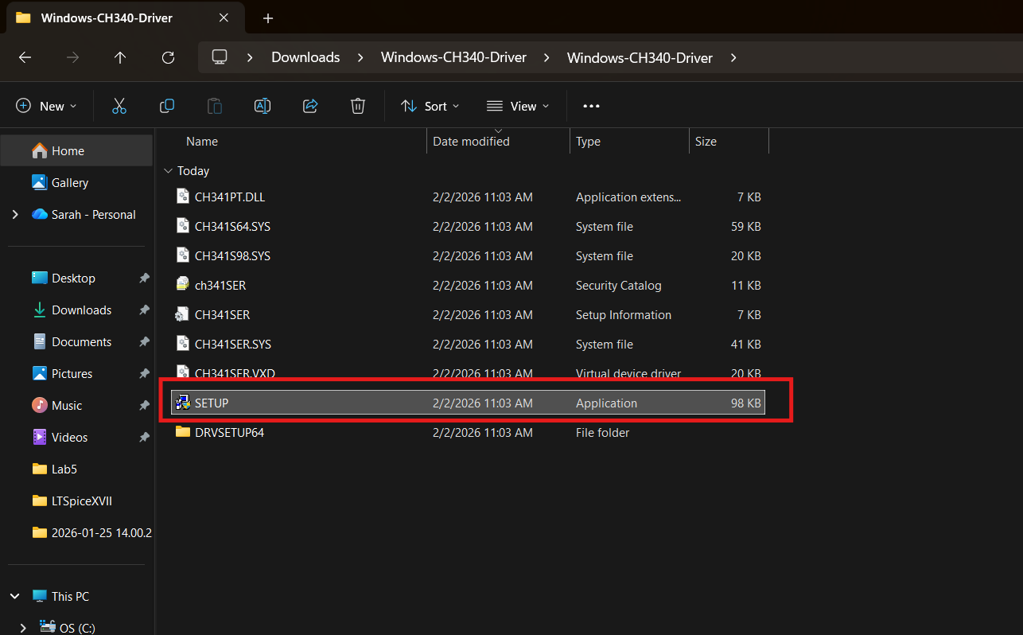

- A window will pop up asking if you want to allow the app to make changes to your device. Click Yes.
- The DriverSetup app will open. Click INSTALL
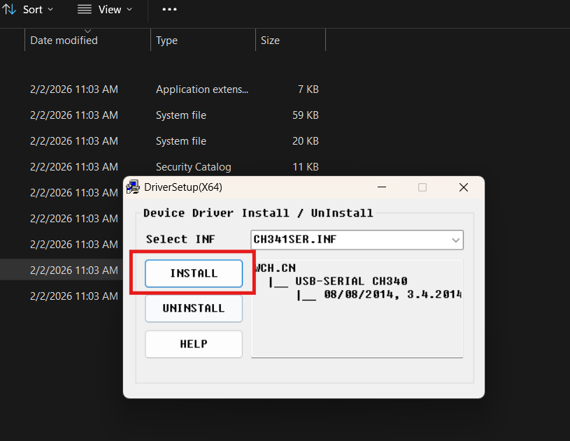

- Looking up COM port:
- Connect the board to your computer. Open Device Manager. Navigate to Ports and expand. Find the COM port number listed for the board.
  - Note 1: If you have another device connected to your computer through its ports (mouse, keyboard, etc.), multiple port listings may show up. Ensure the COM port listing is for the board. Keep this
  - Note 2: The COM port number will be different for every computer and for each port on your computer. Make sure you check the number for the port currently being used.
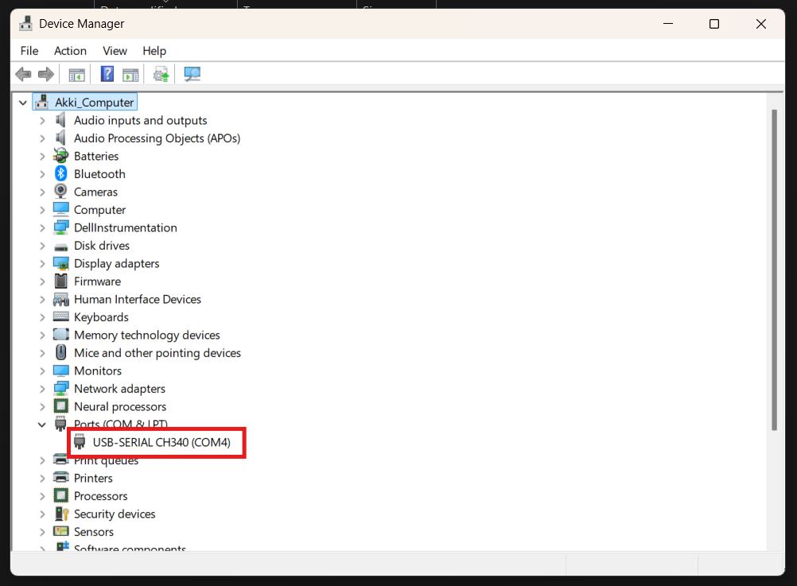

- Downloading and Installing the ceptimus STC89C5x programmer:
  - Download the STC89C5xProgrammer_install.zip file from engreric.com
  - Open File Explorer → Downloads
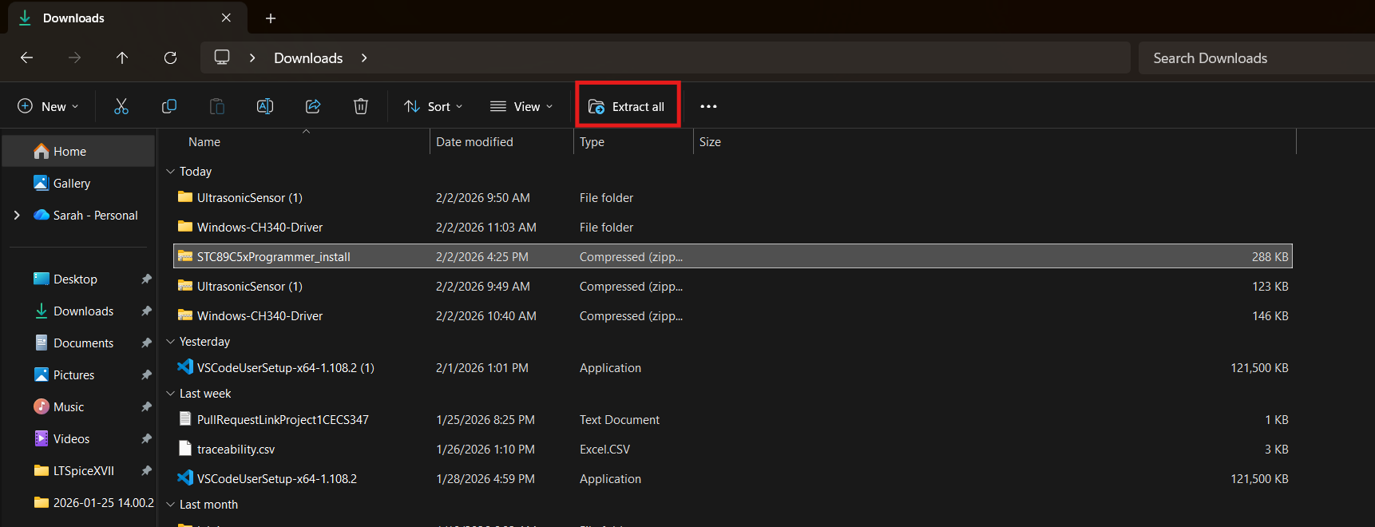
  - Select the zip file and click “Extract all” from the menu.

  - Select Extract on the window that pops up

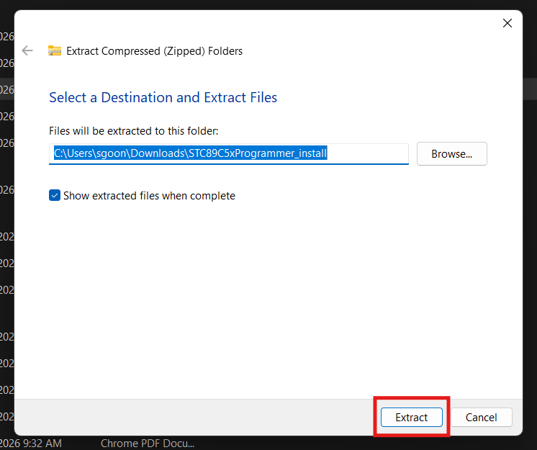

- You will now see a new folder called STC89C5xProgrammer_install. Open this folder.
- Double-click the setup executable to install the programmer.
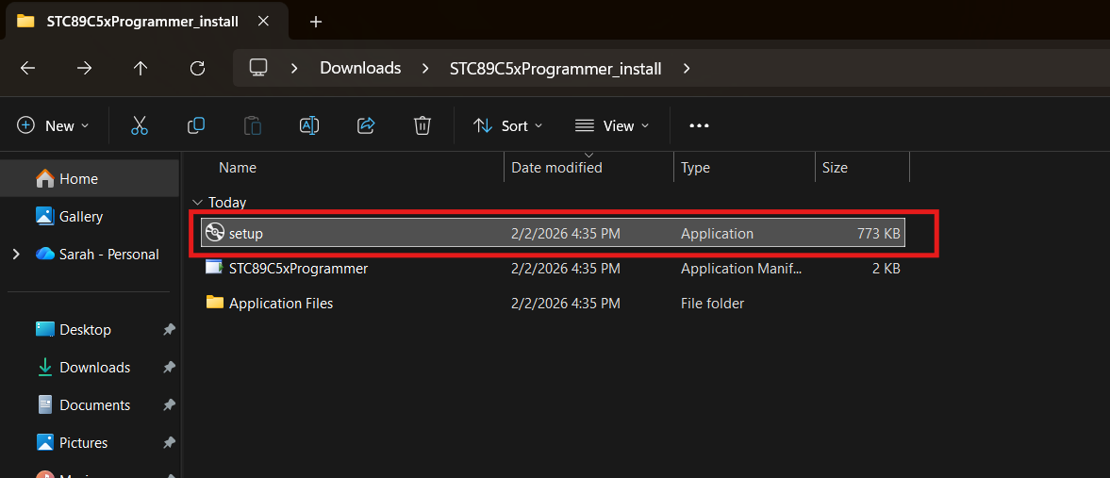

- Windows will show a warning since the publisher is not verified (This can be ignored). Click Install.
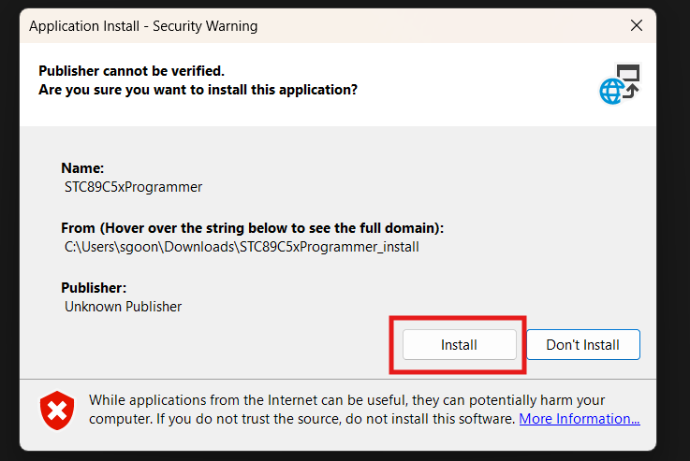

- You may also see this window from Microsoft Defender. Click More info and then Run anyway.
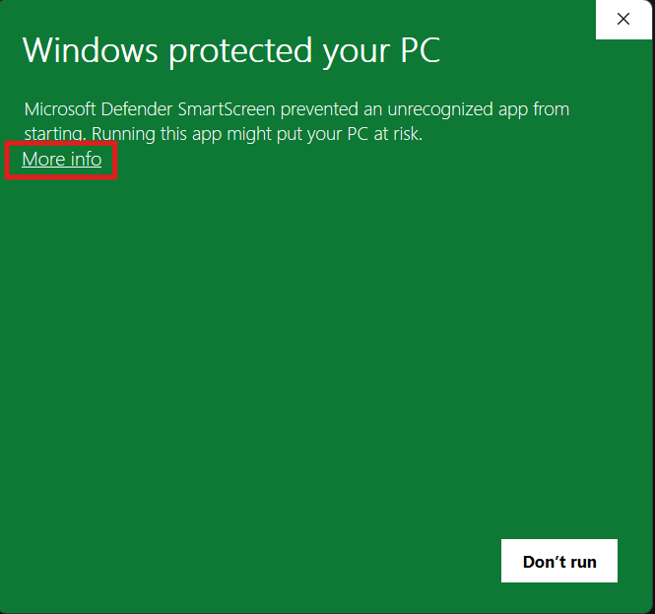
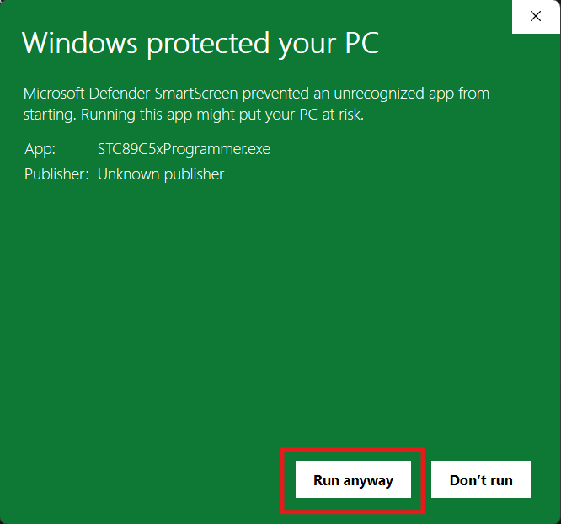

- Once the install is finished, the programmer can be opened.
