- Creating a New Project in Keil
  - Open Keil. Navigate to the top menu and select the Project tab.
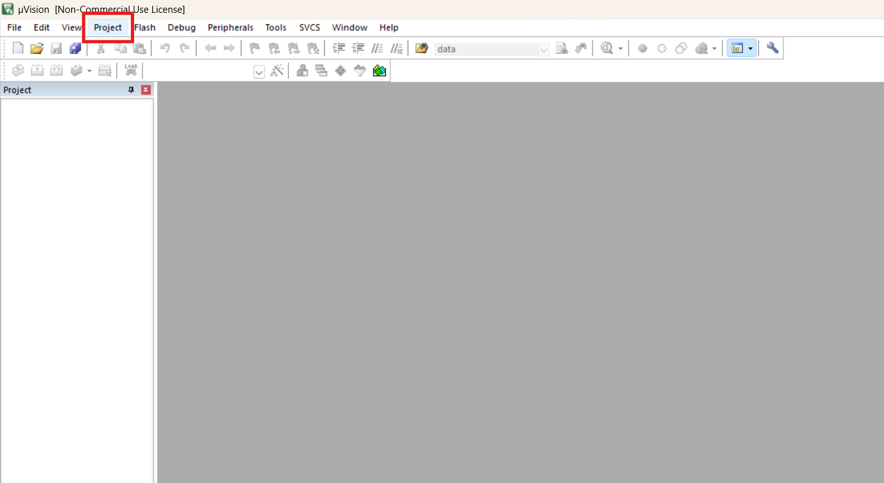

- Click New μVision Project from the Project menu.
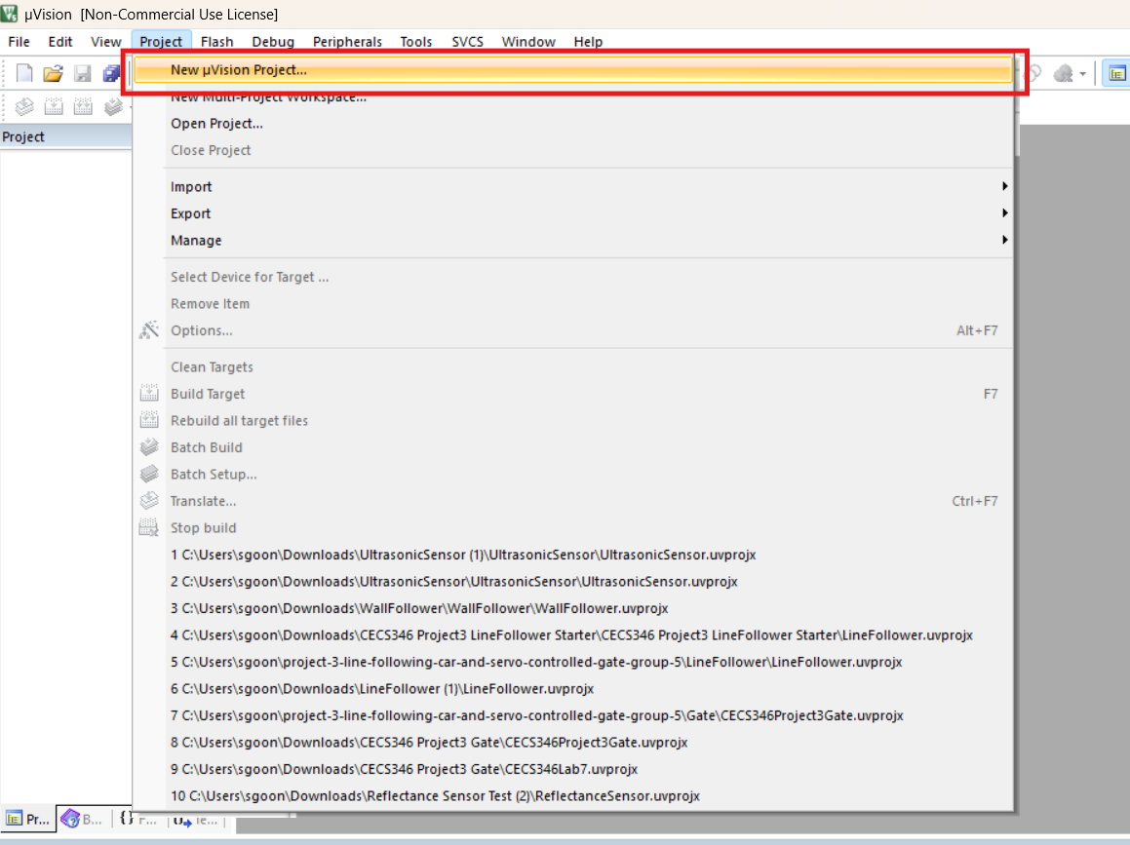

- Name your project and click Save.
  - Note: Place Keil projects in a location you will remember. Also, name projects appropriately so that they do not get misplaced.
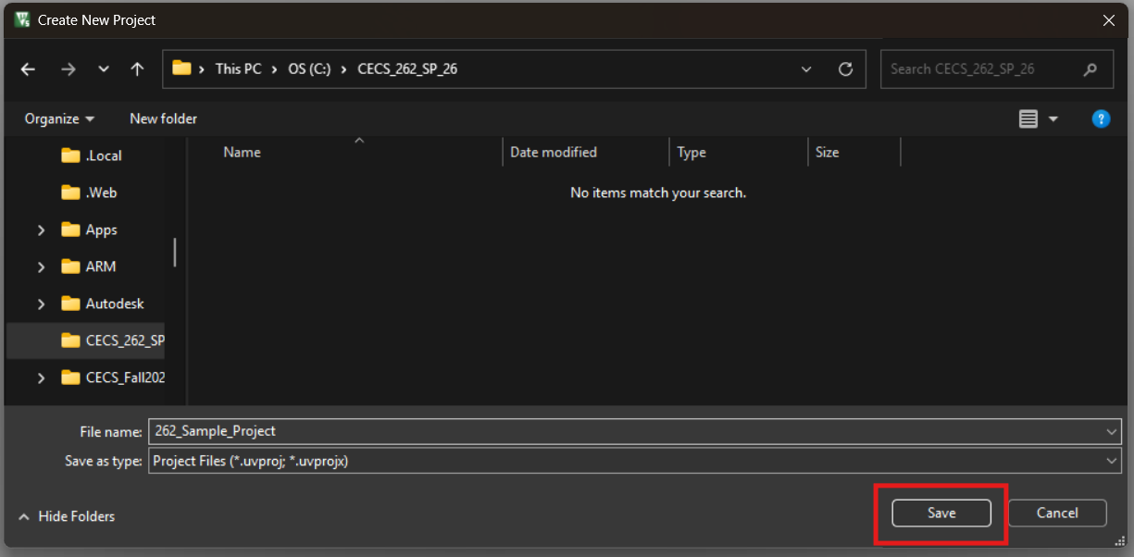

- When prompted to select a device, type 8052 in the search bar. Select 8052 (all Variants) under Generic. Click OK.

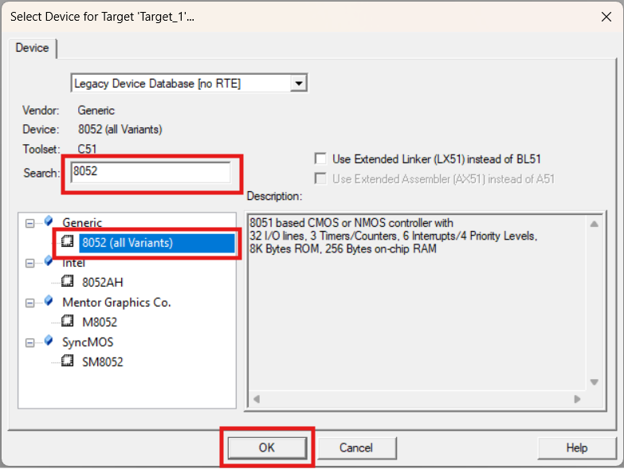
- Create hex file with test code
  - Download the testcode.c file from engreric.com
- Expand the Project panel on the left and right-click on Source Group 1. Click Add Existing Files to Group ‘Source Group 1’
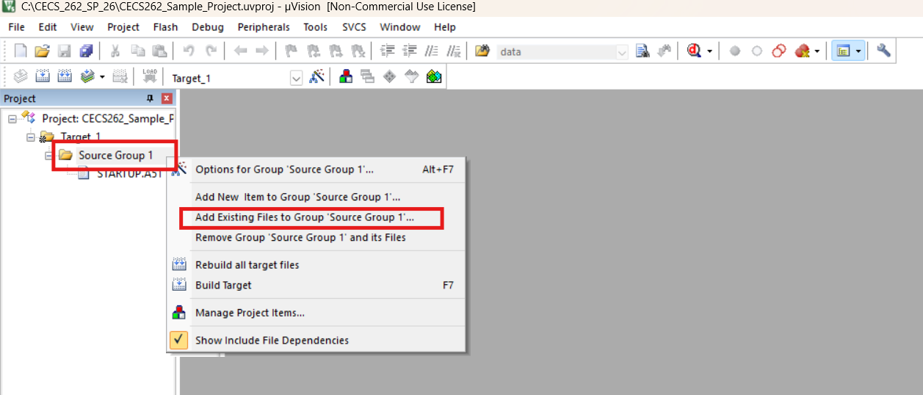

- Select testcode.c from your Downloads folder and click Add. Then, close the Add Files window.
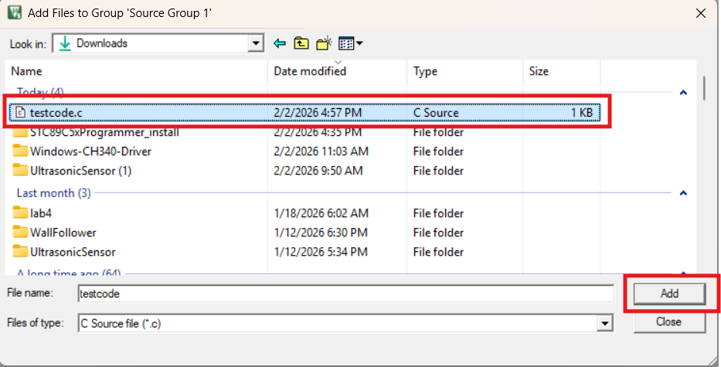

- Right-click Target_1 in the Project panel on the left. Select Options for Target ‘Target_1’
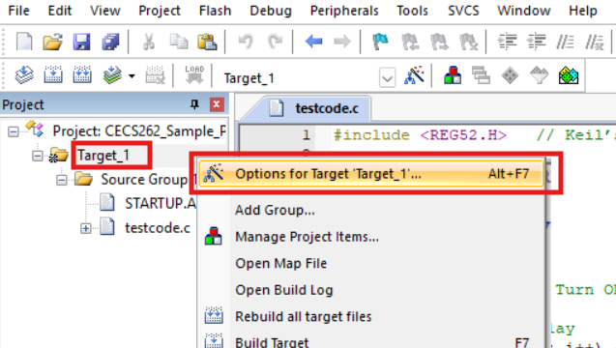

- Navigate to the Output tab. Check the box next to Create HEX file. Click OK.
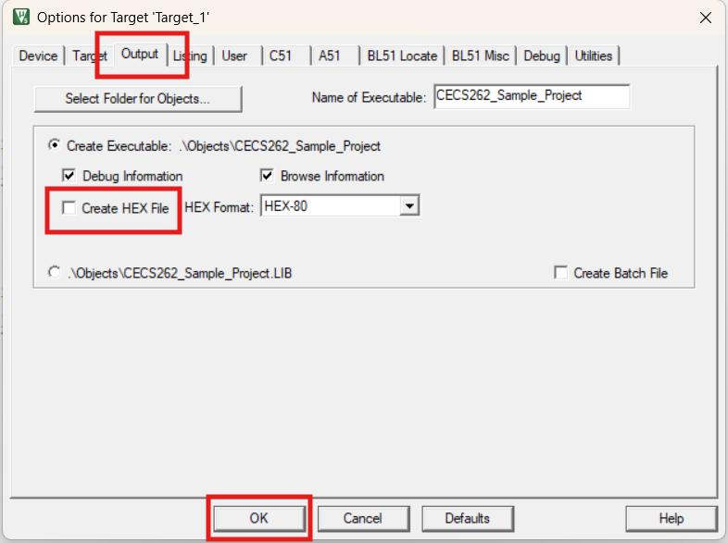

- Double-click the testcode file in the Project panel on the left to open it.
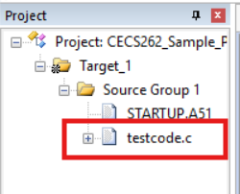

- Click the Rebuild button in the upper left corner menu to recompile your program.

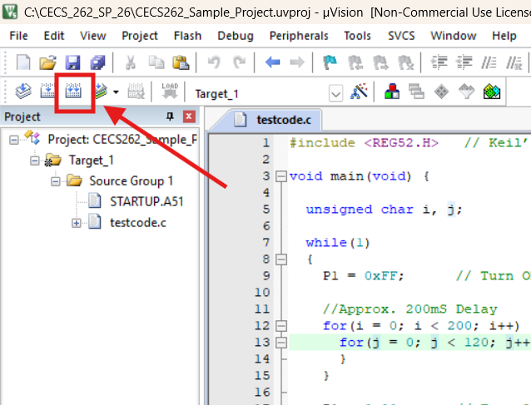

- Watch the Build Output window in the bottom panel.
  - If you see 0 Error (s), 0 Warning (s), then your program has run successfully.
    - If there are any errors or warnings, check your code for issues.

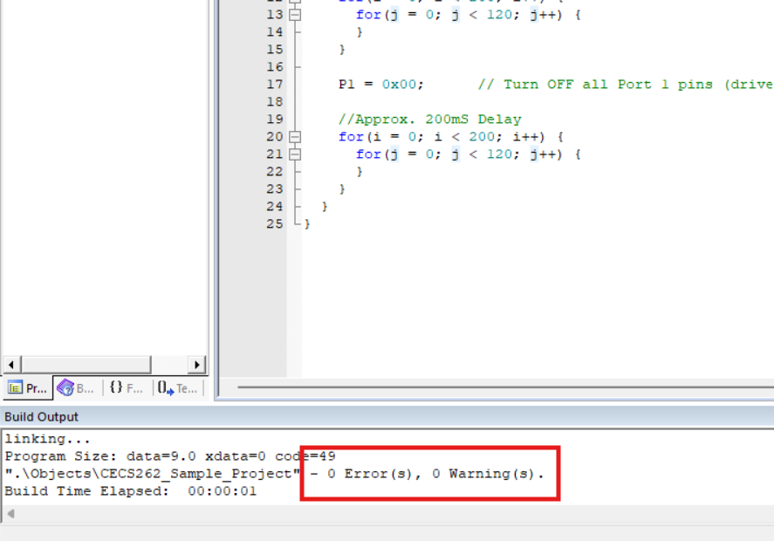

- Open the ceptimus STC89C5x programmer.
- Select the COM port from the dropdown menu. Make sure the number matches the COM port you noted earlier in Device Manager.
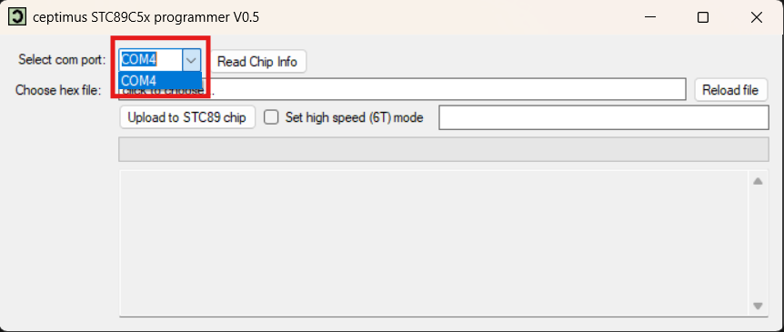

- Select click to choose… and find your hex file. It should be located in the same place you save your project, in the Objects folder. Click Open.
  - Note: You only have to select the file during the first run of your project. For every subsequent run, you can select Reload file instead.
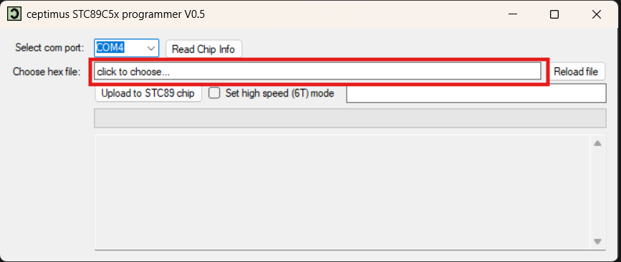
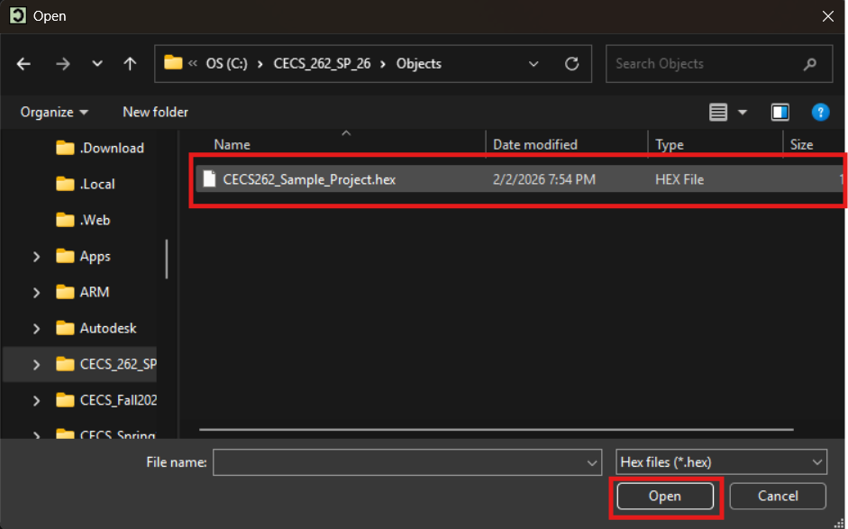

- Now click Upload to STC89 chip
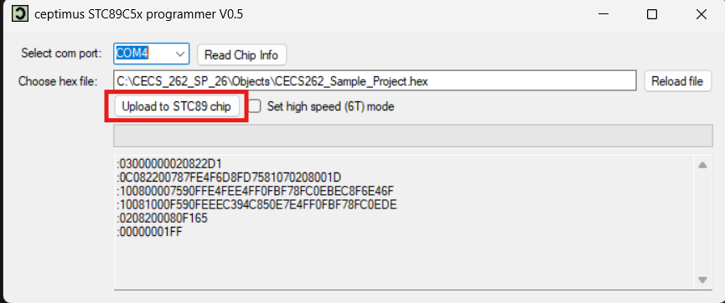

- The green loading bar should now appear.
- In order to allow the hex file to be sent to the board, the board must be switched OFF and then ON again. The power switch for the board is located near the shorter side of the board near the micro USB port.
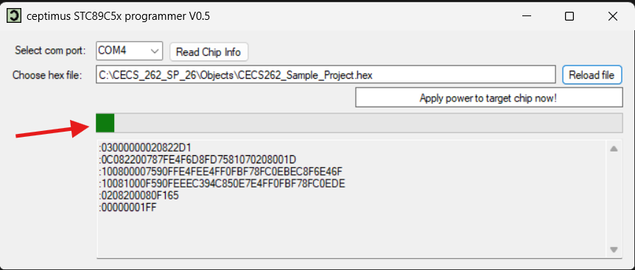

- The green loading bar will finish loading. The hex file should be loaded onto the board.
