NAME: POSSIBLE POINTS: 10

COURSE DATE & TIME:

The Following is an example of a BJT used in a Common Emitter Amplifier circuit.

**Part 1 – Calculation**

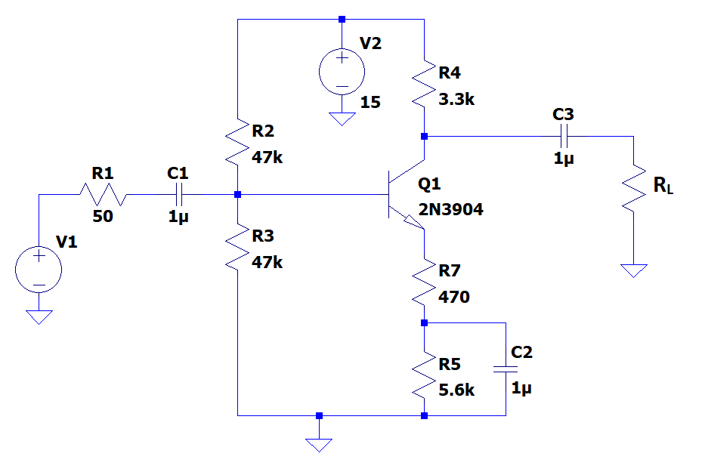

1. Perform a DC Analysis by hand (You may use the estimation technique as opposed to the Thevenin technique), Include a Load Line Analysis and show the Q-Point. Show all your work and include this in the writeup (you may include it hand written and stapled to this lab writeup.

Operational Parameters:

Operating Mode: ______________ IC = ___________ VCE = ___________

Draw the Load Line and Qpoint:

1. Perform an AC Analysis by hand to arrive at your Amplifier Parameters, Av, Zin, Zout. Show all your work and include this in the writeup (you may include it hand written and stapled to this lab writeup.

Av = ___________ Zin = _____________ Zout = _____________

1. For RL = 10K:

Draw the Circuit using the generic amplifier you derived the parameters for and attach a 10K Load Resistor. Make sure to include all input and output impedances.

Use this model to find Vout and Vin.

Vout = ___________ Vin = _____________

Calculated Av (Vout/Vin) = _____________

Error (Av - Calculated Av) = _____________

Is the Calculated Av similar to Av from step 2? If not why, explain in one paragraph….

1. For RL = 1K:

Draw the Circuit using the simplified generic amplifier you derived the parameters for and attach a 1K ohm Load Resistor. Make sure to include all input and output impedances.

Use this model to estimate Vout and Vin.

Vout = ___________ Vin = _____________

Calculated Av (Vout/Vin) = _____________

Error (Av - Calculated Av) = _____________

Is the Calculated Av similar to Av from step 2? If not why, explain in one paragraph….

**Part 2 – Simulation**

1. Recreate this circuit under LT Spice and Simulate.

V1 should equal a 500mVpk 1Khz ac voltage centered at 0v.

RL is a load resistor, initially set this to 10k, we will change it later.

We are running 2 simulation cases, one with the amplifier driving a 10kohm load and another with 100ohm load. Please include a screenshot of the simulation for each case showing the **Waveform** and **Schematic**

1. Include 2 screenshots, one of the 10K load and the other of the 1K ohm load
2. Each waveform should show 5 cycles
3. Label the Input Signal: Vs
4. Label the Input Signal after attenuation by the Zout of the source and Zin of the Amplifier: Vin
5. Label the Output Signal after attenuation by Zout of the Amplifier and Zin of the Load: Vout
6. The Waveform should show Vs, Vin, Vout
7. Take measurements of the waveform using the LTspice measure tool and write these below.

Note: if you take the voltage probe after the output cap, they will all be referenced to 0v and will be easy to compare

|  |  |  |  |
| --- | --- | --- | --- |
|  | Case: RL = 10K | Case: RL = 1K | Calculated Av |
| Vs (pk-pk) |  |  |  |
| Vin (pk-pk) |  |  |  |
| Vout (pk-pk) |  |  |  |

**Part 3 – Breadboard Prototype**

* Create a breadboard prototype of the CE Amplifier from Part 1, Use RL = 10K
* Use the Function Generator to output 500mVpk at 1Khz, verify this directly using the oscilloscope before applying the signal to your amplifier!
* Place Ch1 of the Oscilloscope on Vin before the Amplifier
* Place Ch2 of the Oscilloscope on Vout before the Load
* Include a picture of the waveform from the oscilloscope and annotate with the pk-pk values measured on the oscilloscope, also note the 180deg Phase Shift
* Include a picture of the finished prototype running

Breadboard Measurements.

Vout = ___________ Vin = _____________

Calculated Gain: Av = ___________