NAME: POSSIBLE POINTS: 10
STUDENT ID:
COURSE DATE & TIME:

DIRECTIONS:

Step 1: Solve the Circuit By Hand

You may solve this circuit on the printed copy of this page or include it on a separate sheet of paper. It’s your choice.
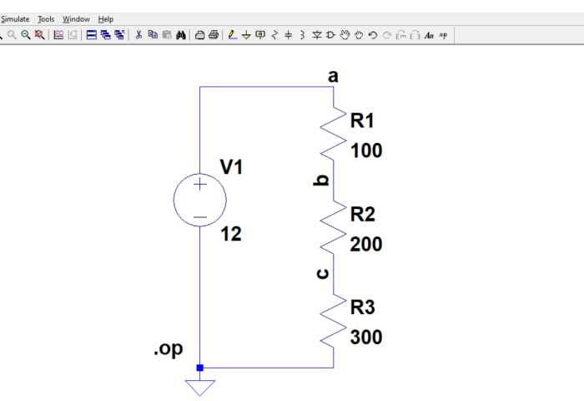

Fill in the following table and questions:

R_{T} |  | The Following 3 voltages are the voltages at node a,b,c. This is different than the voltage across a component. It is taken with respect to a 0v reference, in our case this can be assumed to be the ground symbol
I_{T}
I_{R1}
I_{R2}
I_{R3}
V_{R1} |  | V_{a}
V_{R2} |  | V_{b}
V_{R3} |  | V_{c}
P_{R1}
P_{R2}
P_{R3}

KVL Equation: _________________________________________

Why is I_{R1,} I_{R2,} I_{R3} the same:

Step 2: Create LTSpice Circuit and Run DC Operating Point Analysis

Open LTSpice and create the series circuit with V1,R1,R2,R3. Use the “Label Net” tool to label nodes a,b,c as shown in the circuit. Run a DC Operating Point Simulation.

– Include Screenshot of the Results Here –

Notice the results only show the voltages at the nodes/net labels. From these results, node voltages, calculate V_{R1}, V_{R2}, V_{R3} and show the equation for each:

V_{R1} : ___________________ V_{R2} : ___________________V_{R3} : ___________________

Do these match your calculated values from Step 1? __________________________

Do the currents match your calculated values from Step 1? _____________________

Step 3: Transient Analysis

Change the LTSpice simulation to a Transient Analysis with a 1sec runtime and run.

Take a voltage measurement at the following nodes, inspect the signal to get the precise value and record the values. There is no need to include a screenshot yet.

V_{a}
V_{b}
V_{c}

Do these match step 1 and 2? ______________

Now take a Current Measurement of R1, R2, R3 and inspect the signals to get the precise value. Record these in the following table.

I_{R1}
I_{R2}
I_{R3}

Do these match the results from step 1 and 2? ______________

Now take a Differential Voltage Measurement (Measured between 2 points) across each of the following, inspect each signal and record in the table.

V_{R1}
V_{R2}
V_{R3}

Do these match the results from step 1 and 2? ______________

Now take a Differential Voltage Measurement (Measured between 2 points) across R1 and R2. Inspect the signal to get the precise value and include a screenshot that clearly shows the circuit, the waveform, and the inspected signal for this measurement.

– Include Screenshot Here –

Does this match V_{R1} + V_{R2}? _________________________

Deliverables - Lab Write-Up:

The lab write-up will consist of this document filled out, printed and submitted.

